NAME:- SADAF LULU E
AIM:-
1.USE INPUT() TO ACCEPT THE STUDENT’S NAME AND MARK
2.CONVERT THE MARKS INTO INTEGERS USING EXPLICIT TYPE CONVERSION
3.USE ARITHMETIC OPERATIONS TO CALCULATE THE TOTAL AND AVERAGE
4.USE COMPARISON AND LOGICAL OPERATORS TO CHECK WEATHER THE STUDENT PASSED.THE STUDENT PASSES IF EACH SUBJECT PASSED.THE STUDENT PASSES IF EACH SUBJECT HAS ATLEAST 35 MARKS
5.USE PRINT() TO DISPLAY THE RESULYS IN A CLEAR FORMAT

REQUIRMENTS:-
PYTHON VERSION 3.13
VS CODE INSTALLED
STEPS:-
STEP 1)PRESS “WINDOWS KEY”+ S TO OPEN START MENU
STEP 2.SEARCH FOR VS CODE



STEP3.1)OPEN FILE->2)NEW FILE->3)PYTHON FILE
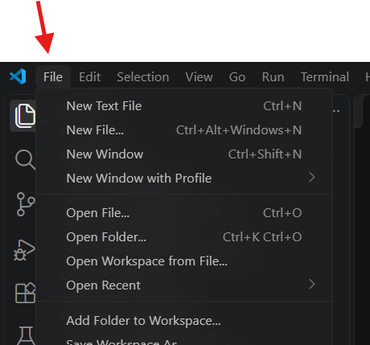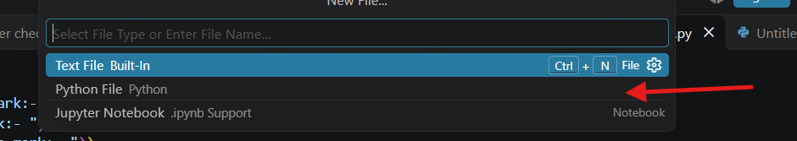STEP4.
3
2
1
INPUT
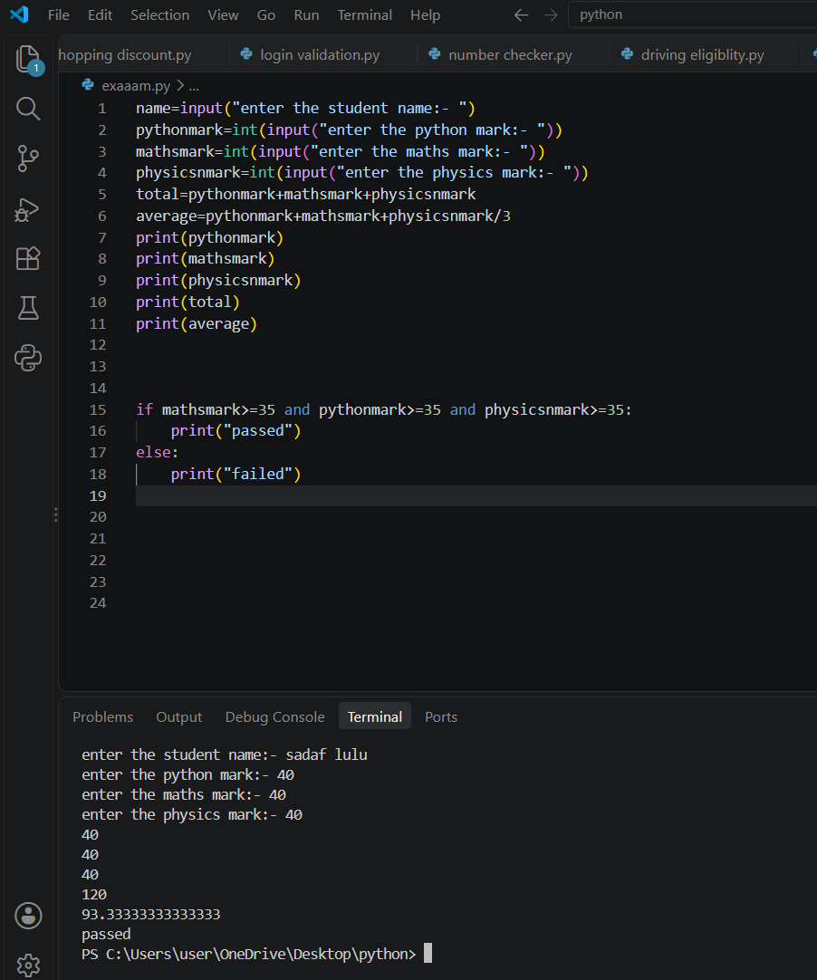

STEP 5.
OUTPUT
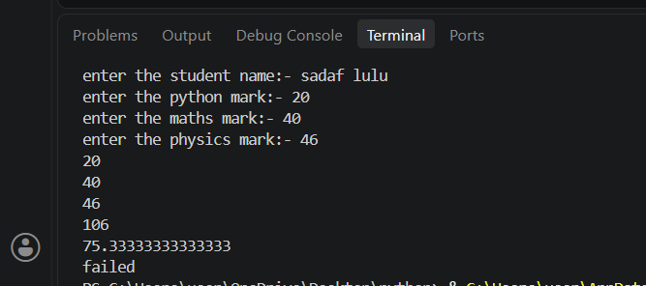
CONCLUSION:-
SUCCEFULLY COMPLETED PYTHON
1.USED INPUT() TO ACCEPT THE STUDENT’S NAME AND MARK
2.CONVERTED THE MARKS INTO INTEGERS USING EXPLICIT TYPE CONVERSION
3.USED ARITHMETIC OPERATIONS TO CALCULATE THE TOTAL AND AVERAGE
4.USED COMPARISON AND LOGICAL OPERATORS TO CHECK WEATHER THE STUDENT PASSED.THE STUDENT PASSES IF EACH SUBJECT PASSED.THE STUDENT PASSES IF EACH SUBJECT HAS ATLEAST 35 MARKS
5.USED PRINT() TO DISPLAY THE RESULYS IN A CLEAR FORMAT

